Knowing your budget
Homebuying is an exciting experience that borrowers dive into headfirst. One of the first questions I ask my new customers is, “Have you thought about what are you comfortable paying for your new mortgage on a monthly basis?” More often than not, the answer is “no” or “not really.” As a homebuyer, you are urged to get prequalified or pre-approval by a mortgage company. This is an important step, but so many times people are tempted or even get their heart set on a property that is really out of their comfortable price range. Your first step as a new buyer should be to review your own budget and figure out what you are comfortable paying on a monthly basis.
When you meet with a mortgage originator, you’ll be asked for your income, assets, and permission to check your credit history. Mortgage companies use various guidelines for allowable total debt compared to total income (called the "DTI" ratio), but remember this is only a guideline. It doesn't represent your whole situation as a homeowner. There are simple steps in creating an effective budget every homebuyer should complete on their own – or we can help you construct the budget when we meet.
First, look at your total monthly income. While mortgage companies usually qualify people based on their gross income (before taxes come out), remember that is not your true take home pay. Look at your paystub and calculate out your monthly net take home pay. Net income means the actual income deposited into your bank account after taxes, social security, health insurance, and any other payroll deductions are taken out. Make a simple spreadsheet listing net take home pay in your “income” category. If you have multiple incomes in your household, list them all in one column and create a “total income” at the bottom.
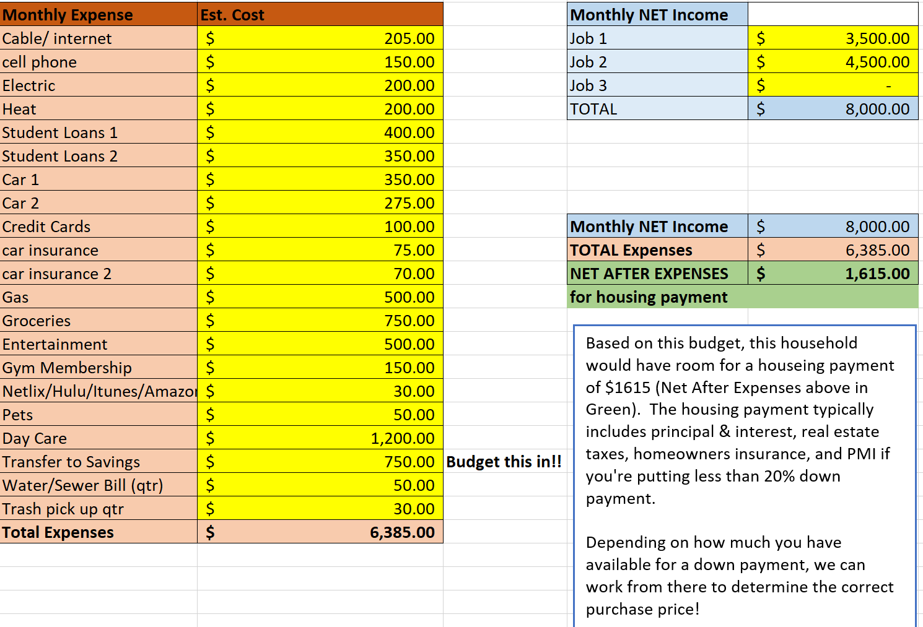
Second, review your monthly expenses. When a mortgage company calculates what you can qualify for, they generally only consider debt that shows up on your credit report. This typically includes loans, mortgages, and credit cards. Remember you have other monthly obligations including utility bills, maintenance, car insurance, and (if applicable) child care expenses that are not usually on your credit report. Create a column for monthly expenses labeled “expenses” and add all of your expenses together at the bottom to create your “Total Expenses” category. If you are paying rent, do not include rent payment in your calculation as the new mortgage payment will take its place.
Finally, subtract your “total debt” from your “total income.” The number you are left with represents your extra money left over to pay for your new house expense.
The housing payment will usually include the principal, interest, real estate taxes, and homeowners insurance. Double check your budget to be sure that you factored in utility bills such as heat, water/sewer tax, electricity, trash removal, and cable.
Surprisingly, your mortgage officer might tell you that you can qualify for more than what you are actually comfortable paying. Creating a budget beforehand ensures you will not get into a situation where you fall in love with a house outside of your comfortable range. Now you are ready to find out from your mortgage officer a reasonable price range based on your comfortable monthly budget. Happy house searching!

Find a copy of our budget worksheet attached here:

